**Write SQL Queries**

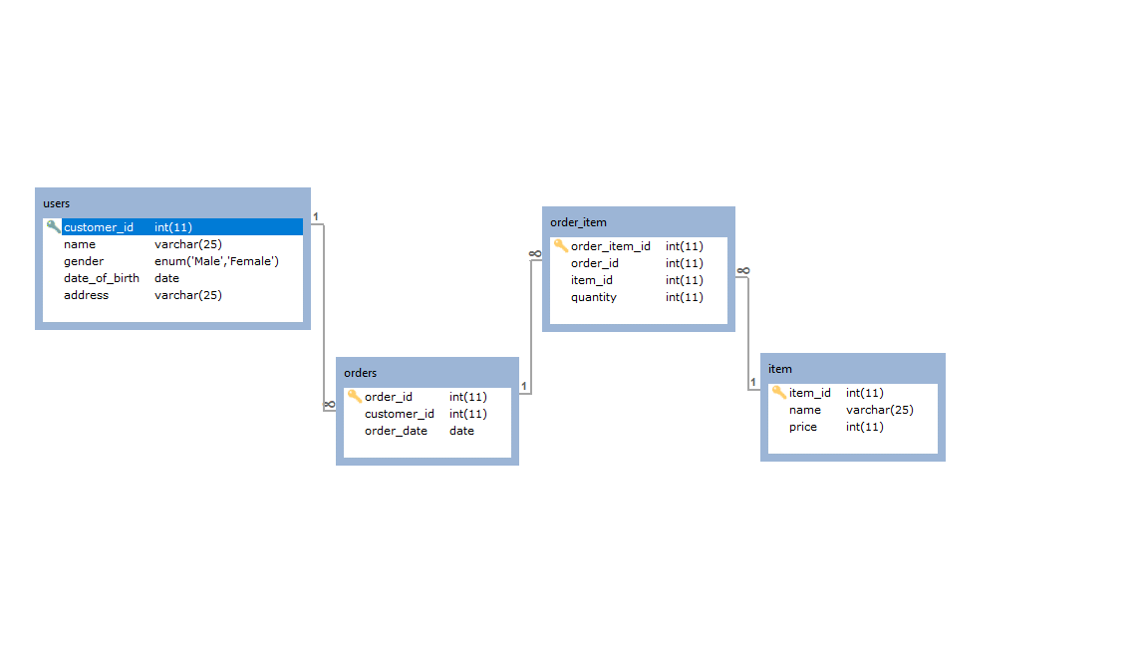

**Query #1**

SELECT users.name, orders.order_id FROM users INNER JOIN orders

ON users.customer_id = orders.`customer_id`;

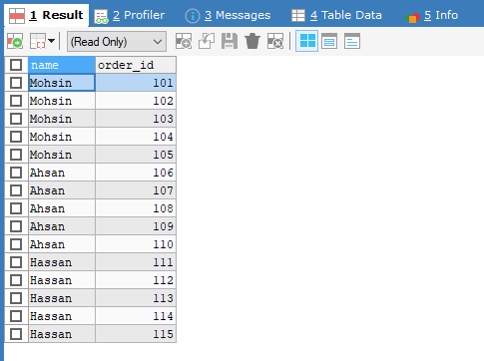

**Query #2**

SELECT users.`customer_id`, users.name, orders.order_id FROM users, orders

WHERE users.customer_id = orders.`customer_id`;

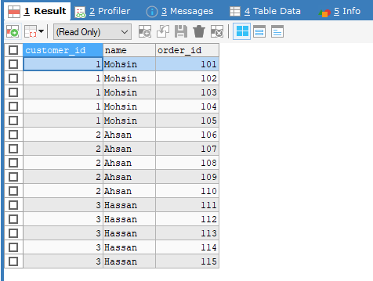

**Query #3**

SELECT * FROM users JOIN orders ON users.`customer_id` = orders.`customer_id`;

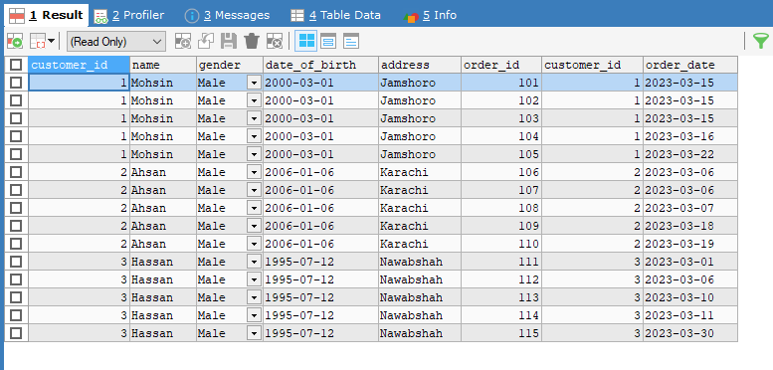

**Query #4**

SELECT * FROM orders JOIN order_item USING(order_id);

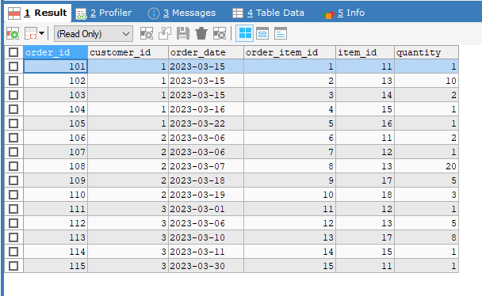

**Query #5**

SELECT order_item.`item_id`, order_item.`quantity`, item.`name`, item.`price`

FROM order_item NATURAL JOIN item;

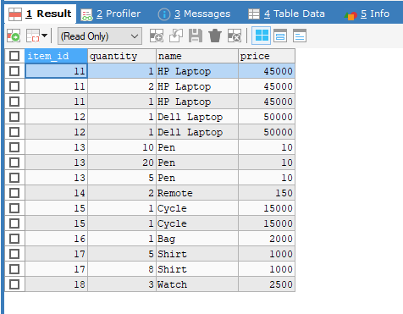

**Query #6**

SELECT order_item.quantity, order_item.order_id, item.name, item.price,

(order_item.`quantity`*item.`price`) 'Sub Total' FROM order_item

LEFT JOIN item ON order_item.`item_id` = item.`item_id`;

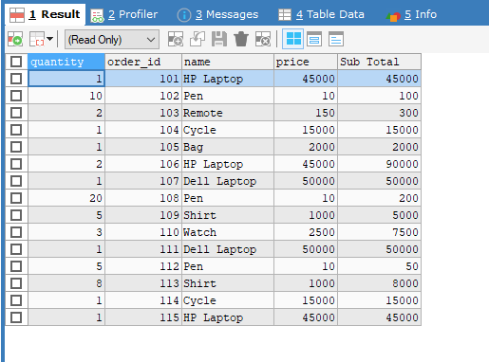

**Query #7**

SELECT order_item.quantity, order_item.order_id, item.name, item.price,

(order_item.`quantity`*item.`price`) 'Sub Total' FROM order_item

RIGHT JOIN item ON order_item.`item_id` = item.`item_id`;

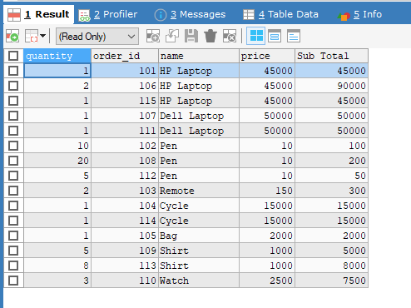

**Query #8**

SELECT * FROM users CROSS JOIN item;

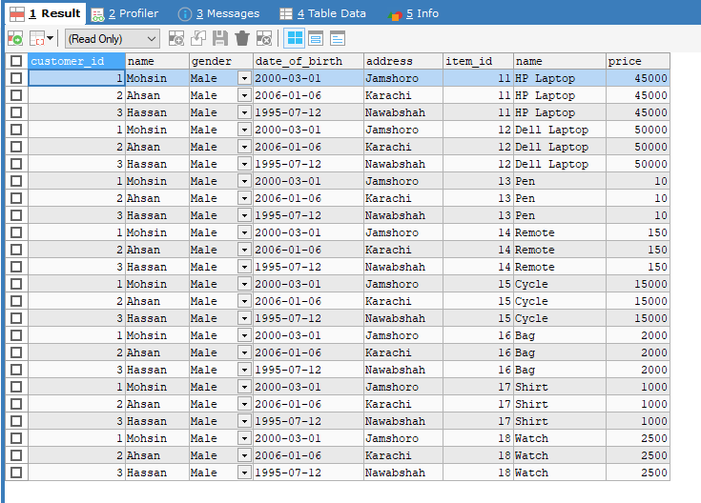

**Query #9**

SELECT i.order_item_id AS 'item 1', q.quantity AS 'item 2'

FROM order_item i, order_item q WHERE i.`order_item_id` = q.`quantity`;

